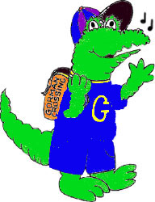
Gorman Crossing Elementary School
9999 Winter Sun Road, Laurel, Maryland 20723
Phone 410-880-5900

January 2, 2014

Dear Parent or Guardian,

On Saturday, April 5, 2014, the annual Howard County Elementary Solo and Ensemble Festival will be held at Ellicott Mills Middle School from 9:00 a.m. - 4:00 p.m. This festival is an opportunity for elementary band and string students currently enrolled in our school’s instrumental music program to perform solos and small group ensembles (duets, trios, quartets etc.). All soloists and small ensembles will have ten minutes to perform their music before an adjudicator. The adjudicator will give both verbal and written feedback of the performance - very much like a short private lesson. Students will also receive a certificate for their participation. As you can see, students will gain many benefits from participating in this festival.

If your child elects to participate, I will assist her/him in selecting and learning the appropriate music. I will also be sending home the schedule of events at the end of March that will include your child’s performance time and room assignment.

In order to participate your child must fill in the attached registration form and return it me by Monday, February 3, along with the registration fee. Checks should be made payable to “Gorman Crossing Elementary School” or “GCES” and must include your child’s name, your name and your telephone number.

If you have any questions, please contact me at school. Thank you for your support of the instrumental music program.

Sincerely,

Ronald D. Bowman
Band and Strings Teacher

